HOLMDEL VINEYARD VINES
CUSTOM T SHIRT ORDER FORM
William R Satz Fundraiser
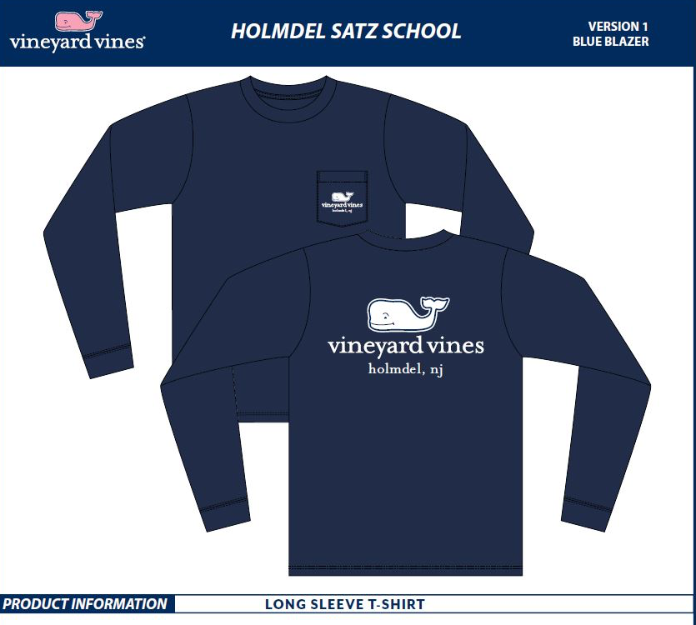

Adult Sizes | XS | Small | Medium | Large | XL | XXL |  | Total
$45.00 ea. |  |  |  |  |  |  |  | $
Children’s Sizes | 2T | 3T | 4T | YSM | YM | YL | YXL | Total
$25.00 ea. |  |  |  |  |  |  |  | $
Please indicate quantity of each size

STUDENT NAME: _________________________________________

GRADE:_____
TELEPHONE#:_____________________ EMAIL:_____________________________
TOTAL QUANTITY of SHIRTS ORDERED: ______________
TOTAL PAYMENT ENCLOSED $ ______________ CHECKS ONLY

ALL ORDERS DUE NO LATER THAN OCTOBER 31ST - NO ORDERS ACCEPTED AFTER THIS DATE. Delivery by 12/20/2017 --PLEASE MAKE CHECKS PAYABLE TO SATZ PSG.
THIS FUNDRAISER IS SPONSORED BY WR SATZ PSG

