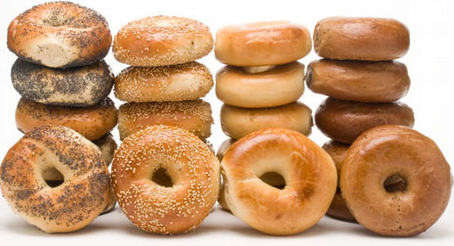

INDIAN HILL SCHOOL SNACK DAYS FUNDRAISER
SPONSORED BY THE PLG
Please help support our students by purchasing a SNACK PACK for distribution during your child’s lunch period, during these upcoming 4-hour session days of school:
Friday, November 15, 2019
Monday, November 18, 2019
Tuesday, November 19, 2019
Wednesday, November 27, 2019
All SNACK PACKS MUST be pre-ordered and paid for in advance by using the attached Order Form. We regret that SNACK PACKS will not be available for purchase on the 4-hour session day.
Please return the completed order form and the cash or check made payable to the “Indian Hill PLG” in a sealed envelope marked as: “PLG-SNACK PACK” and due no later than:
Wednesday, November 13, 2019
We thank you for your continued support! Any questions? Please contact Meagan Solomon Rodgers @ plgpresident1@gmail.com
~~ A SPECIAL THANKS TO HOLMDEL BAGELS ~~

